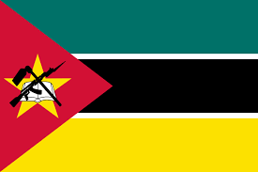
Visa Application
Passport Type
Present Nationality
Name as Written in Passport
Date of Birth
Reason for Travel (if business please provide name of the company you will be visiting.)
Email
Phone Number

Passport Information
Passport Number
Date of Issue
Date of Expiry
Country Issued By
Town/City of Birth
Country of Birth
Nationality at birth

Additional Information
Occupation
Religion
Workplace
Current Address
Telephone Number
Proposed Entry Date
Visa Period (30 days, 60 days, 90 days)
Proposed Exit Date
Visa Type

Sponsor Information (IF APPLYING FOR BUSINES VISA)
Is your sponsor a person or organization?
Relationship (IF sponsor is a person) or Name of Company
Address
Telephone Number
Website (IF Applicable)

Emergency Contact
Name
Address
Email
Telephone Number

More Additional Information
Where would you like to receive the Visa | BORDER
Issuance Location
Method of Travel
Flight Number or Vehicle ID
Address in Mozambique
Province in Mozambique
District in Mozambique

