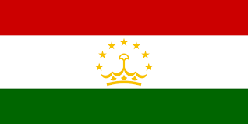
Visa Application
Country of Citizenship
Applicant Type (Individual or Sponsor)
Do you have a GABO permit? (YES/NO)
Visa Type
Purpose of Visit
Entry (Single or Multiple)
Middle Name
Family Name(s)
Given Name(s)
Gender
Marital Status (Include Spouses Name and Nationality IF married)
Date of Birth
City of Birth
District of Birth
Country of Birth
Telephone Number
Residential Home Address
Expected date of Arrival in Tajikistan
Address in Tajikistan (where you will be staying)
Name and Phone Number of Contact in Tajikistan

Passport Information
Passport Number
Country Issued By
Date of Issue
Date of Expiry
Have you EVER been to Tajikistan before? (IF yes, please include a copy of your previous visa)

